Flask Application: is a web application framework written in Python. Flask is based on the Werkzeug WSGI toolkit and Jinja2 template engine. Both are Pocco projects.

Installation:
We will require two packages to set up your environment. virtualenv for a user to create multiple Python environments side-by-side. Thereby, it can avoid compatibility issues between the different versions of the libraries and the next will be Flask itself.
virtualenv
pip install virtualenv
Create Python virtual environment
virtualenv venv
Activate virtual environment
windows > venv\Scripts\activate
linux > source ./venv/bin/activate
Flask
pip install Flask

Working with Flask Application
Prerequisites: Before getting started with flask one should Install Python>=3, configured with PIP (Python Package Index) on our computer.
Installing Flask:
To install flask all we need to do is just run this single command on our system command prompt.
pip install flask
Writing out first traditional program “Hello World!”
- Firstly, we need to import Flask Class from flask module which we installed earlier, this Flask class will contain all the methods and attributes that we use in writing our application, so this will be our first line in our program.
from flask import Flask
- Secondly, we need to declare a variable containing a flask object. This variable will be used for running and configuring our app.
app = Flask(__name__)
“__name__” is a special variable in Python. If the source file is executed as the main program, the interpreter sets the __name__ variable to have a value “__main__”. If this file is being imported from another module, __name__ will be set to the module’s name.
- Writing Main Function
In our main function, we need to run our flask variable, to do that we need to use the app variable which we declared before and use the run method on it. This run method starts a local server in your machine. Usually, the default address is “localhost:5000.” To change the port address, we can pass in a parameter to the run method assigning it to any desired port number. We need to restart our server whenever we change the code in our application, to overcome that we can use debug parameter given to run the method and set it to “True”. Now, whenever if there are any changes made to the source code the server automatically restarts. The debugger is also used to track the errors if there’re any. Below is the code snippet of the main function.
if __name__ =="__main__":
app.run (debug=True, port=8080)
4. Routing
We then use the route () decorator on the app variable to tell Flask what URL should trigger our function. The desired URL pattern should be written in the string to the route decorator. The function which should be triggered by the route will be declared under it. Below is the code snippet of how to declare a route.
@app.route('/')
def hello_world():
return 'Hello, World!'
“/” is the home route, as soon as you run your server it triggers first.
5. Running the Flask application.
Once all the above steps are complete, now our source code looks like this.
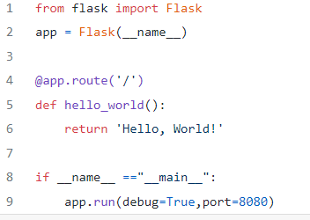
3.Android application with Flask server
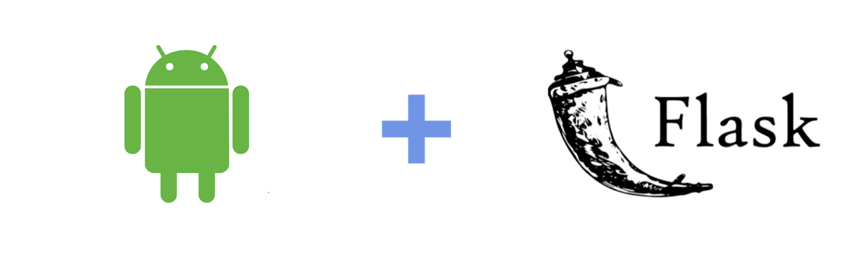
We all know that mobile devices are powerful compared to PCs, we can do a lot of things with our smartphones with limited resources, and most of us consider that an advantage. So, we can conclude that mobile devices are the best choice for many things such as machine learning.
REST APIs:
REST APIs communicate via HTTP requests to perform the communication between your front-end application and the database! Just like you are in Asia with your mobile application and the database is hosted on a server in America. You need an agent to establish the connectivity between your mobile app and database, isn’t it?? This is the point where you implement your own REST API. It will communicate with your central database using the functions you implemented to perform CRUD. Your front-end application establishes a connection and makes HTTP requests to retrieve data from the database. The REST API you implemented will work on those requests and send you the data as the HTTP response.
The initial use case was that I was workinsg on a machine learning-based mobile application and there I needed to do pre-processing and predictions using python and python-compatible libraries. Hence it was a significant requirement to have a python backend and that’s where I stepped into ‘Flask’! In this approach, we can send our data from Android to the Flask server via REST API calls and do the python related processing inside the flask server and get the output back to our android app via REST API call. Here It is using okhttp, a third-party library developed by Square for sending and receiving http requests.

